Predictive Analytics for Pricing Strategies and Revenue Optimization
Abstract
Pricing has emerged as a key determinant of a firm's competitiveness and success in the modern digital economy. Previously, traditional pricing methods were used, which included adding costs on top of the buying price or fixed pricing, and this often failed to react quickly to demand, competition, or market conditions changes. This study mainly targets to focuses on how the use of predictive analytics combined with machine learning may make pricing more easily, data-driven, and dynamic in order to get around it. This research work presents a hybrid predictive framework that combines three models-Random Forest, XGBoost, and LSTM each was chosen for its strengths in handling complex, time-based retail data. Hence thereby to make this framework stand out above all other frameworks is that it also integrates explainable AI techniques, specifically SHAP and LIME, which make the model’s predictions transparent and understandable for business users, especially those who don’t have technical knowledge. Although real SME data was limited when carrying out this research due to business privacy reasons, a synthetic retail dataset was created to simulate realistic price-demand patterns. After that, the models were being evaluated using the standard metrics which include MAE and RMSE, to measure their accuracy. The results which were produced, they show that this approach can help to achieve strong balance between the performance and interpretability, as it not only predicts accurately but also explains why it reached those conclusions. After all things, this study provides small and medium-sized businesses a space option to implement AI-driven pricing systems that are inexpensive, moral, and simple to comprehend, even in the absence of sophisticated technical resources.

Introduction
Price is the single most direct tool that a firm uses to optimize sales, profit, and survive in a tough competitive market. Slight changes in the pricing of a product can strongly affect both revenue and customer behavior. In today’s digital markets, customers can compare prices instantly (like on Amazon or Flipkart), information spreads fast, and buying decisions change quickly. So businesses should be able to react in real time, not just relying on old traditional pricing methods. Dynamic pricing is defined as ‘price changes that are prompted by changes or differences in four key underlying market demand drivers which are people, product configurations, periods, and places’ [1]. Businesses require pricing that is mainly driven by data, not based on speculation. In most firms, analytics and artificial intelligence are now commonly used to study demand patterns, seasonal effects, competitor actions and promotional impacts. These may bring an insight to most companies to decide how they will set practical prices. Traditional, most of the pricing strategies were based on the concepts like marginal costing and price elasticity. Today however machine learning methods allow prices to be adjusted more dynamically as the market changes [2]-[4].
Using a mixture of statistical models and supervised learning techniques, businesses are able to see how the customers will react to the different price levels and use that information to guide their revenue plans. [5] Models such as Random Forest and XGBoost are particularly more useful because they can capture interactions between the sales, discounts, and pricing that are difficult to notice manually. However, predictive analytics transforms pricing from a reactive operational approach into a proactive, strategically optimized process guided by interpretable machine learning insights.
1.1 Background
Modern predictive systems combine intelligent learning, pattern recognition, and traditional economics. These applied all together allow firms real-time pricing decisions, which simply means adjusting prices automatically as the market changes. “While direct profitability uplift figures from predictive analytics adoption are not always explicitly reported, EY’s study found that companies that invest in pricing analytics and raise prices by over 5 % are significantly more likely to achieve growth and remain committed to analytics investments” [6]. Pricing analytics has become an essential tool for businesses in today’s highly competitive and rapidly changing marketplace [6]
1.2 Problem Context
The use of AI by Small and Medium businesses is limited because they don’t have enough clean data, they can’t afford expensive hardware, and they also lack technical experts. Hence, this research is more focused on SME on how to apply analytics in order to maximize revenue due to the correct application of pricing strategies. So while big firms can use AI pricing, SMEs are left behind. Even if SMEs use AI, managers may not trust it, and they can't interpret the results, which raises transparency and ethics problems that’s why there is use of SHAP and LIME in this research to make it usable to SME. “New global policies (like the EU AI Act 2024) now require AI systems to be explainable and fair, especially when they affect customers directly, so businesses have to make sure their AI is interpretable” [7].
1.3 Role of Predictive Analytics in Revenue Optimization
Different Machine Learning approaches work together in order to capture all kinds of patterns, RF & XGBoost, these are cross-sectional relationships, and LSTM temporal patterns. By adding explainable AI tools such as SHAP and LIME, one can see which factors influenced the prediction, eg, how much discount or competitor price impacted the output. This will only be able to increase trust and interpretability, which is the main key for business decision-making. This study designs an AI framework that runs on small computers so SMEs can afford it.
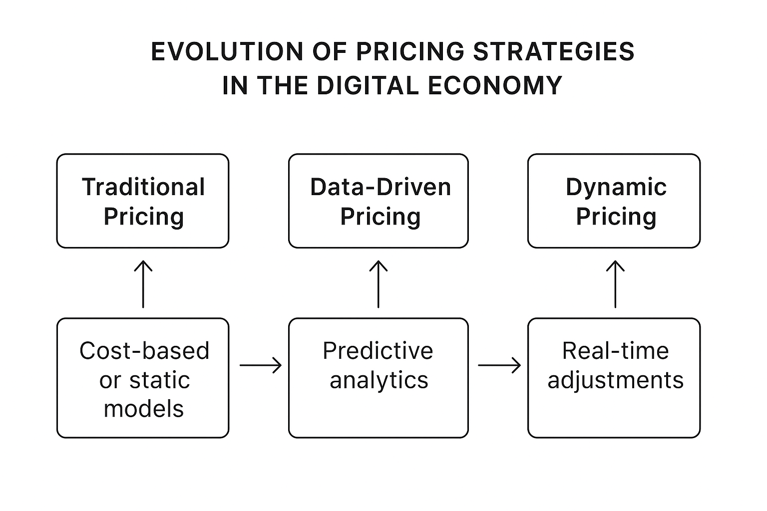
Figure 1: Evolution of Pricing Strategies in the Digital World. Created by the author
Fig. 1: A diagram that shows how pricing strategies have changed over time due to modern digital world. Earlier methods were mostly based on simple cost calculations or sometimes fixed price rules. As Businesses has started collecting more data, pricing has become more analytical and even with models that could forecast demand and guide the business decisions. The latest stage is dynamic pricing where the pricing will be updated instantly depending on demand, completion or other market conditions.

Literature Review
2.1 Dynamic Pricing and Predictive Analytics
Dynamic pricing refers to the practice of adjusting product prices in response to real-time market conditions such as demand shifts, competitor actions, or inventory levels. In earlier years, many firms mostly relied on fixed cost or cost-plus pricing approaches, and these were slow to react to changes in the market [8],[9]. The wider adoption of data analytics has changed this approach. Instead of using simple rules, companies are now applying predictive models that estimate how the customers might respond to pricing changes, which helps them to balance revenue goals with issues such as perceived fairness [10]. In a more practical way, the adjustments may take seasonal trends, competitor promotions, or even weather patterns into account. Therefore as a result, pricing decisions are mainly guided more by ongoing market evidence than by static traditional methods, which is particularly important in markets where conditions shift quickly.

Ref. No | Paper/Book Title | Methods Used | Dataset Used | Key Findings | Limitations
[8] | The Strategy and Tactics of Pricing: A Guide to Growing More Profitably (Nagle, Hogan & Zale, 2016) | Strategic and managerial pricing frameworks, economic theory, segmentation, value-based pricing models | No empirical dataset (conceptual/industry examples) | It has showed how value-based pricing and segmentation improve profitability and competitive strategy | It lacks real-time pricing insights and data-driven/machine learning approaches; mainly conceptual
[9] | Pricing and Revenue Optimization (Phillips, 2021) | Optimization models, demand estimation, price elasticity modeling, revenue management algorithms | There is no specific dataset used-it uses hypothetical or illustrative business cases | It shows how quantitative optimization improves pricing decisions and revenue outcomes | This mainly focuses more on theoretical and mathematical models rather than modern predictive analytics or big data
[10] | Dynamic Pricing Method in the E-Commerce Industry Using Machine Learning (Nowak, Sałek & Król, 2024) | Machine learning models-regression, forecasting, feature-based pricing algorithms | It uses real-world e-commerce transaction and pricing dataset | ML-driven dynamic pricing improves pricing accuracy, competitiveness, and revenue; captures seasonality & competitor effects | It is limited to one industry/dataset; there might be potential model bias, data dependency, and interpretability concerns

Overall, from the studies they have suggested that machine learning can support pricing methods that react better to the market changes than the older fixed or cost plus models. At the same time, much of the existing work looks mainly on bigger firms. Issues such as how understandable of the models are or how small firms can use them with limited resources, are often overlooked. This gap has highlighted the need for pricing approaches that are easier to apply in more practical way in a day to day business settings.
2.2 Machine Learning Models for Predictive Pricing
The recent studies have explored the use of machine learning models and artificial intelligence systems in order to improve pricing prediction accuracy and adaptability in real-world dynamic markets. Mostly tree-based ensemble methods, such as Random Forest and Extreme Gradient Boosting, have been widely applied due to their ability to model complex, nonlinear relationships between pricing determinants, even with moderately sized datasets [11], [12]. Hence, the models have been able to effectively capture variable interactions, making them suitable for heterogeneous retail and e-commerce data environments [13].
In contrast, deep learning models such as Long Short-Term Memory networks are particularly effective for time series-based pricing because they can learn long-term dependencies and temporal dynamics in demand and price sequences [14], [15]. Recent studies suggest that using tree-based ensemble models together with time-series approaches can improve both the accuracy and the interpretability of the price forecasts [16] .
To add on for the Small and Medium Enterprises (SMEs), such models, which were used in this research project, are particularly appealing because they do not necessarily require high-performance computing resources and can operate efficiently on smaller systems [17]. Hence, this makes them an applicable solution for small businesses that lacks people with more technical knowledge or large budgets but still seeking to benefit from AI-driven pricing [18].

Ref. No | Paper Title | Methods Used | Dataset Used | Key Findings | Limitations
[11] | Ticket Sales Prediction and Dynamic Pricing Strategies in Public Transport (Branda, Marozzo & Talia, 2020) | Random Forest, dynamic pricing optimization models | The dataset which was used is real-world public transport ticketing & demand data | It demonstrates machine learning demand forecasting and supports revenue-optimized pricing decisions | The results findings from this is limited to transport industry-may not generalize to retail or e-commerce
[12] | Comprehensive Analysis of Random Forest and XGBoost Performance… (Imani et al., 2025) | Random Forest, XGBoost with SMOTE, ADASYN & GNUS | Benchmark datasets with varying class imbalance | Tree-based ensembles remain highly accurate even under imbalance when combined with resampling | It is not focused on pricing-computational cost increases with imbalance techniques
[13] | Enhancing Retail Demand Forecasting with XGBoost (Balusani et al., 2025) | XGBoost vs ML & DL comparative models | Retail sales and demand time-series dataset | XGBoost outperforms deep learning for structured retail forecasting | Working-paper status-limited methodological transparency
[14] | Integrating Attention-Enhanced LSTM and PSO for Dynamic Pricing… (Liu et al., 2025) | Attention-based LSTM, Particle Swarm Optimization | Fresh-food supermarket pricing & inventory dataset | Hybrid LSTM models improve price forecasting and replenishment accuracy | It is computationally heavy-less suitable for SMEs with limited hardware
[15] | Day-ahead Electricity Price Prediction Applying Hybrid LSTM Models (Li & Becker, 2021) | LSTM, feature-selection-based hybrid deep learning | Electricity market time-series pricing data | Temporal deep learning effectively captures volatile price fluctuations | This was mainly domain-specific to energy markets-not retail-pricing focused
[16] | Research on Stock Price Prediction Based on LSTM and Random Forest (Qi, 2024) | LSTM+ Random Forest hybrid model | Financial stock price datasets | Combining temporal and tree-based models increases predictive performance | This applies to financial trading-not product or consumer pricing
[17] | Automated Demand Forecasting in SMEs (Gärtner, Lippert & Königorski, 2024) | Lightweight ML forecasting models | Case-based SME operational datasets | ML forecasting feasible without high-performance computing-supporting SME adoption | It works with limited sample size which lacks extensive evaluation across industries
[18] | Artificial Intelligence in SMEs: Enhancing Business Functions… (Le Dinh, Vu & Tran, 2025) | Applied AI and decision-support ML models | SME case studies and organizational data | AI improves operational efficiency and supports data-driven decision-making | Conceptual-does not provide empirical model performance metrics

Collectively, prior work indicates that tree-based ensembles and LSTMs perform well in forecasting demand and pricing outcomes. Therefore, the limited research integrates these models within hybrid architectures or evaluates them in resource-constrained SME environments, thereby highlighting the need for scalable and explainable predictive systems.
2.3 Challenges faced by SME in Adoption of Predictive Pricing
Despite having the numerous advantages of predictive analytics, Small and Medium Enterprises encounter several obstacles when they try attempting to implement these technologies in their business. The most commonly reported challenges include data being limited probabily due to privacy issues of firms, high implementation costs, and insufficient technical experts [19], [20].In most noted cases, Small to Medium Enterprises lack very large, well-structured datasets, hence this will make it difficult to train reliable predictive models. To mitigate this issue, recent studies have recommended the use of synthetic dataset generation or transfer learning approaches, where models trained on large-scale datasets are adapted for smaller business contexts [21].
To add on, the other major barrier involves financial and resource constraints. Several studies have pointed out that many small firms struggle to adopt predictive pricing systems because they require strong computing resource and the trained staff, which might be costly [22]. Apart from the financial studies, issues of trust and clarity also matter. Many business owners hesitate to use pricing algorithms if they cannot see how the model arrives at its suggestions. As Kopalle et al. [23] note managers are more open to using these tools when the system clearly explains the reasoning behind the pricing recommendations.

Ref. No | Paper Title | Methods Used | Dataset Used | Key Findings | Limitations
[19] | Trends and Challenges towards Effective Data-Driven Decision Making in UK SMEs (2018) | This one it make use of qualitative case study analysis, business analytics | This used the case studies from 85 UK SMEs | This one identifies the lack of quality on data, analytics skills, and organizational readiness as major barriers to data-driven decision-making | It does not address modern ML or predictive pricing adoption challenges
[20] | AI-Driven Business Analytics for SMEs: Unlocking Value through Predictive (2024) | It uses AI and predictive analytics conceptual framework | It makes use of secondary SME business research reports | It highlights AI’s value creation potential but notes privacy, cost, and data access issues | It lacks empirical validation and it is mostly theoretical discussion
[21] | Small-Sample Data Pricing Based on Data Augmentation and Meta-Learning (Shen, Yang & Xiao, 2024) | It uses data augmentation, meta-learning, and pricing prediction models | The use of small-sample pricing datasets | It shows that synthetic data and meta-learning improve model performance for SMEs with limited data | The model is more complex, and it may exceed SME technical capability
[22] | Breaking the Digitalization Barrier for SMEs (Restrepo-Morales et al., 2024) | The fuzzy logic decision-support model, digital transformation analysis | Small to Medium Enterprices organizational survey datasets | It shows that financial constraints, infrastructure gaps & workforce skills hinder digital adoption | It focuses broadly on digitalization-not pricing-specific
[23] | Dynamic Pricing: Definition, Implications for Managers… (Kopalle et al., 2023) | Managers pricing analysis, behavioral adoption frameworks | It is mainly literature-based conceptual and industry examples | Manager adoption improves when pricing models are transparent and explainable-interpretability drives trust | It does not propose technical ML interpretability models
To conclude this section, many small and medium businesses recognize that predictive pricing could help them, but most still struggle with the costs, the technical skills required and the limited data they have. Several studies provide ideas or partial solutions but what’s still missing is a complete and practical pricing approach that smaller firms can actually afford and understand.
2.4 Explainability and Trust: Using SHAP and LIME
Explainable AI tools such as SHAP and LIME have recently become more important for understanding how predictive pricing models behave in real business practices. SHAP, developed by Lundberg and Lee [24], assigns a contribution value to each feature so that the users can see which inputs are more driving the model’s output. LIME, which was proposed by Ribeiro et al. [25], takes a different approach by creating a simple local model around a single prediction to show why the model suggested that particular price.
In pricing contexts, these tools help managers see why a model is reacting to factors such as demand, stock levels, or competitor activity. Previous studies note that combining the two methods improves transparency and helps build trust-something that matters even more for SMEs, where pricing choices are often based on personal judgement or past experience [26], [27]. Moreover, the explainability techniques will help to mitigate bias and make sure it enhance fairness by enabling users to keep in track and validate their model behavior [28].

Ref. No | Paper Title | Methods Used | Dataset Used | Key Findings | Limitations
[24] | A Unified Approach to Interpreting Model Predictions (Lundberg & Lee, 2017) | SHAP, game-theoretic feature attribution, model-agnostic explainability | It makes use of multiple benchmark machine learning datasets | Introduced SHAP, enabling consistent and mathematically grounded explanations of feature contributions | It is computationally expensive for large datasets.
[25] | Why Should I Trust You?: Explaining the Predictions of Any Classifier (Ribeiro, Singh & Guestrin, 2016) | It makes use of LIME, local surrogate models, interpretable regression | This makes use of classifier evaluation datasets used in KDD experiments | It then proposed LIME, providing instance-level explanations that improve user understanding and trust | Here the explanations may vary due to random sampling-stability concerns
[26] | Peeking Inside the Black-Box: A Survey on Explainable AI (XAI) (Adadi & Berrada, 2018) | It uses systematic survey of XAI models, SHAP, LIME, surrogate interpreters | It makes use of literature review across multiple Artificial Inteeligence domains | It highlights importance of interpretability for trust, transparency, and accountability. | It does not mainy focuses on specifically on pricing or SME applications
[27] | Explainable Artificial Intelligence: A Systematic Review (Vilone & Longo, 2020) | Comprehensive XAI review-post-hoc and intrinsic interpretability | It make use of public datasets referenced in reviewed studies | It demonstrates that explainability increases managerial confidence and user adoption of AI systems | It mainly the theoretical part hence it lacks real-world pricing implementation
[28] | A Survey on Bias and Fairness in Machine Learning (Mehrabi et al., 2021) | Fairness frameworks, XAI evaluation, bias mitigation | It makes use of multi-domain datasets-finance, healthcare, marketing | It shows SHAP/LIME help detect bias, improving fairness and ethical compliance | It focuses on fairness broadly not dynamic pricing specifically
Taken together, the literature confirms that SHAP and LIME improve transparency, managerial trust, and ethical adoption of pricing models. However, these techniques are not commonly used in real-world business pricing systems, particularly within SMEs, suggesting a critical research opportunity.
2.5 Research Gap and Our Contribution
Although the studies that exist before demonstrate the effectiveness of machine learning in pricing, most focus on large enterprises, require extensive historical datasets, or lack interpretability. The limited research specifically investigates affordable, explainable, and hybrid predictive pricing frameworks designed for SMEs. Hence this study is here to addresses this gap by proposing a cost-efficient architecture that integrates Random Forest, XGBoost, and LSTM with SHAP and LIME explainability, that enables transparent and practical pricing decisions suitable for data-constrained SMEs.
From the prior research studies, it demonstrates that machine learning can achieve better pricing accuracy and profitability, but hence existing studies often faces four key limitations, which are listed below:
a) Most models for pricings are developed for large enterprises and assume access to extensive historical datasets.
b) High-performance algorithms such as XGBoost or LSTM are very rarely combined with explainability tools, leaving decision-makers without insight into model behavior.
c) SME-focused studies examine AI adoption generally rather than implementing pricing-specific predictive frameworks.
d) There is no existing work that provides a low-cost, interpretable, hybrid machine learning architecture validated on small, realistic retail datasets.
Therefore, the current literature lacks a practical, transparent, and resource-efficient predictive pricing model tailored to SME constraints a gap this study addresses.

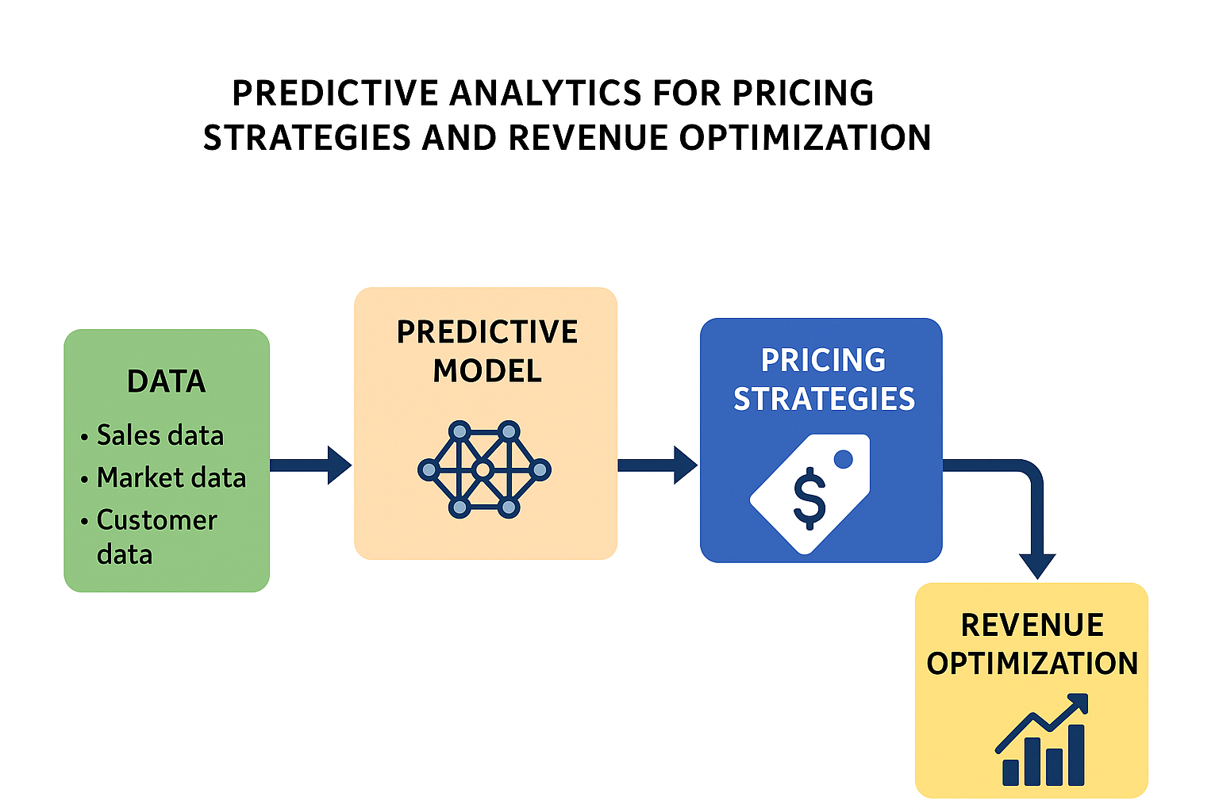
Figure 2: Predictive Analytics Framework for Pricing Optimization (Data → Predictive Model → Pricing Strategies → Revenue Optimization) Created by author
Figure 2 shows us how the predictive analytics data is being used in pricing strategies in order to optimize revenue. The first step shows that it's gathering data. The data to be gathered will include sales, market, and customer data. After gathering data, the second step includes feeding data into a predictive model making sure utilizing AI and machine learning in order to identify market trends and consumer behavior. Next will be pricing strategies- the model insights inform the development of informed and potentially dynamic pricing strategies. The last step will be revenue optimization, which is the ultimate goal of data data-driven approach is to maximize revenue and profitability.
Overall, the reviewed studies really show that hybrid machine learning and explainable AI systems can do a lot for SME pricing, but there’s still not much real proof from hands-on research. Many studies have tried to explain why AI could help to improve pricing, but very few actually test solutions that are being simple, affordable, and easy for small business to use. Because of this, gap our work focuses on building a model that predicts prices and also shows its reasoning clearly what are the contributions to the changes. This is important for SMEs, since they usually rely on experience and need to understand how the system arrives at each conclusion and recommendations.
3. Methodology

In this study, we use a synthetic retail dataset to explore how predictive analytics can support pricing and revenue decisions. The workflow combines the standard machine learning models with the explainability tools so that the results will be both accurate and hence interpretable. All the experiments were carried out in python, mainly relying on Tensorflow, Scikit-learn, XGBoost, SHAP and LIME. These tools were selected because they are well established in the literature and hence allow the analysis to be reproduced easily.
Since this research is mainly targeting SMEs, real retail datasets that are complete were not used due to issues of privacy of businesses, and synthetic data was created for this study, which represents real business scenarios. That made it easier to implement the framework we suggested and still keep realistic relationships between price and demand and real-world applicability of business. Our model is a combination of Random Forest, Extreme Gradient Boosting and Long Short Term Memory in order to make the model give accurate results.
The four stages are as below :
• Generating Data and Preprocessing of the Data: This stage involves making and preparing synthetic data that represents real market behavior.
• The modelling process was developed gradually- It begins with selecting the algorithms that could offer stable and more meaningful predictions.
• After the initial models were built, explainability tools were added so that the results we be easier to interpret. SHAP and LIME were used for this purpose because they allow the researcher to see which features are influencing the output and how the model arrives at particular suggestions [24], [25].
• The final stage involves checking how the models performed. Standard evaluation measures such as MAE, RMSE, R², and Revenue Uplift Percentage (RUP) were applied to compare the different approaches and understand where each method had performed well.
After all, the overall workflow was designed to balance prediction accuracy with clarity and responsible model behavior. This aligns with the principles of transparency and ethical use of AI that have been highlighted by organizations such as the IEEE Global Initiative on Ethics of Autonomous and Intelligent Systems [29] and the OECD [30].

3.1 Data Generation
To carry out the analysis, a synthetic dataset was created to present day-to-day retail behavior for a single product. The dataset created covered 1,200 days and includes variables that typically influence pricing decisions such as the product price, discounts, competitor prices, marketing activity, elasticity, weather conditions and seasonal patterns. These features help simulate the fluctuations in demand or revenue that often arise from economic shifts or environmental changes [31].
Before the modelling step, the dataset was cleaned and prepared. Scaling was applied using Min-Max Normalization and the StandardScaler so that the features were on comparable ranges, which generally helps most learning algorithms train more effectively [31]. Any missing values were filled using the median of each variable and columns that were not meaning for prediction such as date, product ID, or units sold- were removed to avoid adding unnecessary noise to the model.
The preprocessing steps:
- The first one is dropping the non-predictive columns (like date, product ID, and units_sold).
- Filling of the missing values using median imputation.
- Applying Min-Max Scaling for neural models and Standard Scaling for ensemble ones.
- Data Splitting into training and testing sets 80% and 20% which came out to about (960, 9) for training and (240, 9) for testing.
A correlation heatmap (Figure 3.1) was made to see how different variables related to each other like in case price and revenue. This step helped to pick the best features and check if any of them were too closely linked, which can sometimes confuse the model.
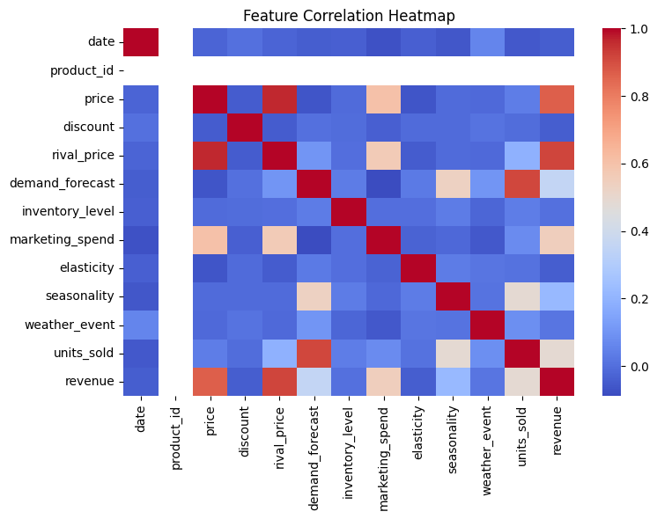
Figure 3.1: Feature Correlation Heatmap – generated via Seaborn visualization
3.2 Model Development
In this research study, four different predictive models were built and compared in order to understand which approach performs best for price and revenue optimization
- The first one, Linear Regression, is used as a baseline model for all the models. It provides a simple way to measure how much improvement the more advanced models achieve.
- Random Forest Regressor was applied as a more complex, ensemble-based method. A maximum tree depth of 12 was chosen to balance accuracy and overfitting.
- The XGBoost Regressor was then used in order to further improve predictive accuracy.
- Long Short-Term Memory (LSTM) was also used to in order capture temporal patterns in the data -that is, how today’s prices depend on previous days.
All four models were performed using Python frameworks -Scikit-learn, XGBoost, and TensorFlow Keras - which provide reproducibility, transparency, and consistency for machine-learning experiments.

3.3 Model Evaluation Metrics
The performance of the model was evaluated using the following:
• Mean Absolute Error (MAE)-This will enable us to measure the average magnitude of prediction errors.
• Root Mean Squared Error (RMSE)- This has helped us to provide a penalized measure for large deviations.
• Revenue Uplift Percentage (RUP) - This helps to quantify the amount of percentage improvement in RMSE as compared to the baseline Linear Regression model.
The above-used metrics in this research help to take into account both the predictive accuracy and stability of each model used in estimating the revenue.
3.4 Explainability and interpretability of the Results
The first one used SHAP, which measures how much each feature contributes to the model’s final prediction. In this research study, it showed that SHAP consistently showed that price, discount, and rival price were the most influential features in determining predicted outcomes. However, during certain experiments, a known formatting issue in the XGBoost library caused SHAP to skip its calculations, which is a common limitation when models are saved or reloaded in a specific format.
LIME, on the other side, focuses on explaining individual predictions rather than overall model behavior [24]. In this research project, LIME was mainly targeted Random Forest model to identify which specific features influenced a single prediction the most.
Let's take for example, if the model predicted a high revenue on a particular day, LIME could show whether that outcome was driven by a lower price, a higher discount, or a competitor’s price change. Together, SHAP and LIME provided a balanced and transparent view of model interpretability-SHAP explained the global trends, while LIME clarified local, case-by-case predictions-enhancing both the trust and transparency of the AI system [25], [32].

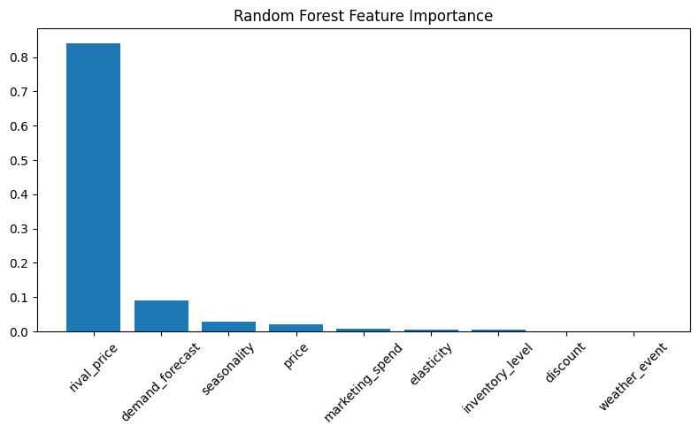
Figure 3.2: Random Forest Feature Importance Plot
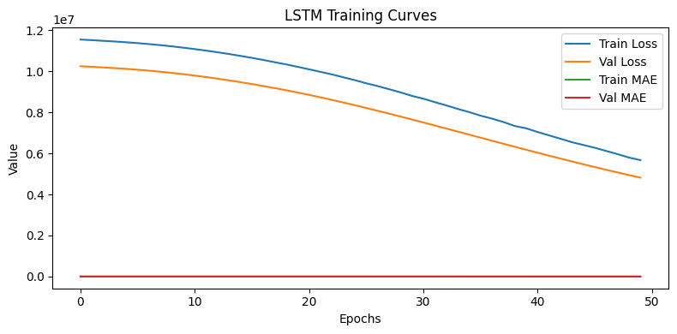
Figure 3.3: LSTM Training Curves.
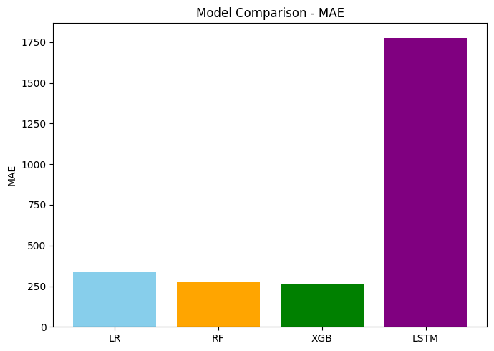

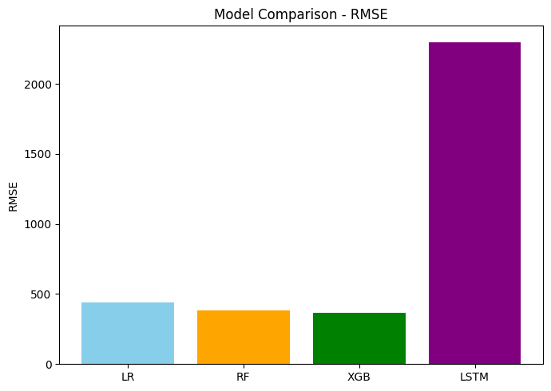
Figure 3.4: Model Comparison Bar Chart

4. Results and Discussion
4.1 Model Performance Summary
The Table 4.1 represents a summary of the comparative performance of all four models used in this research study.
RUP = (RMSE_{baseline} – RMSE_{model)/} RMSE_{baseline}
Model | MAE | RMSE | RUP(%) | Remarks
Linear Regression | 337.10 | 440.90 | - | Baseline Model
Random Forest | 275.15 | 384.41 | +12.81 | Improved non-linear fitting
XGBoost | 262.42 | 365.51 | +17.10 | Best-Performing ensemble
LSTM | 1778.08 | 2299.31 | - | Underperformed due to scientific noise and short temporal depth

4.2 Discussion of the Findings
The ensemble-based models, which are used, Random Forest and XGBoost, have shown that they clearly outperformed the baseline linear regression model. Among all of them, XGBoost achieved the lowest RMSE(365.51) and MAE(262.42), reflecting roughly about 17% improvement in predictive accuracy over the baseline. To add on, the LSTM model has produced much higher error values. Possibly this underperformance is mainly linked to the limited temporal depth of the synthetic dataset and the presence of noise, which hindered the model’s ability to capture sequential patterns.
4.3 Visualization Insights
The visual analytics generated by the pipeline reinforced interpretability and pattern recognition :
- Feature Correlation The heatmap displayed moderate positive correlation between price and rival-price, and an inverse relationship between price and units-sold.
- The Random Forest Feature Importance Plot highlights that price and discount are the main contributors to revenue difference.
4.4 The interpretation of the results shown and their implications.
The results suggest that the ensemble models, especially XGBoost, were more dependable for this type of retail revenue forecasting. They gave good accuracy without being too heavy to run, and they were still fairly easy to interpret. The use of SHAP and LIME also helped to make the model decisions clearer, since they highlight which factors are pushing the predictions up or down, which is useful for smaller firms that need practical explanations. The LSTM did not perform well as expected in this synthetic setting, but it was included to show how the approach could be extended to real retail data where customer behavior changes over a time span.
Overall, the analysis points to the value of combining several modelling ideas together. Using regression, ensemble methods and deep learning alongside explainability tools creates a more flexible and little bit understandable pricing system that can help businesses make better revenue-related decisions. For Small to Medium Enterprises, the XGBoost model’s ability to generalize across limited data implies cost-effective automation of price recommendations
5. Limitations
From this research study, it provides an extensive framework for predictive pricing and revenue optimization, but of course, there exist some certain limitations that cannot be left out.
The dataset that was used for training the models is scientific generated, whereby it may not fully capture all of the complexities, market shocks, and exact effects present in the current real-world retail data. These results findings are supported by the statement from other studies “Simulated datasets may not capture all market shocks, whereas multi-product transactional datasets from real retailers increase external validity “[33], [34].
Secondly, the framework was implemented to only limited single-product which might not provide us with very accuracy results because some products are cross product and forecasting, which eases interactions that occur in various multi-product or cross-category ecosystems. Also, the hyperparameter tuning and optimization were restricted to mirror SME resource environments only.
Furthermore, the study uses SHAP and LIME as post-hoc explainability tools. Though they are widely adopted in explainability AI research, “these methods lead to variable interpretations when applied to correlated or sequential data” [36].
Finally, the overall aspects of AI-driven pricing were examined conceptually, but they were not empirically validated. Also, research should conduct user- or policy-level studies to explore how transparency and explainability influence fairness, compliance, and trust [33], [34]. Additionally, integrating predictive pricing pipelines into existing SME systems can face many challenges related to data integration and privacy compliance [35].

6. Conclusion and Implications
The results have indicated that the models were being able to help improve prediction accuracy and also support increases in the expected revenue. Together, these results findings they suggest that machine-learning-based pricing tools could be more valuable for the small firms that want to move beyond simple pricing rules.
Key Conclusions:
• The study shows that combining several learning methods tends to work better than using a single traditional model. In the experiments, the hybrid setup achieved a revenue improvement of around 17.10%.
• The analysis also points out that competitor pricing, discount levels, and demand forecast strongly influences revenue. This highlights how important it is for the firms to use pricing approaches that consider market conditions rather than relying only on cost-based methods.
• Last Using synthetic data allowed the model to be developed and tested without dealing with privacy concerns, while still giving a reasonable idea of how the framework could behave in a real retail setting.
Taking all together, the work suggests that SME-oriented pricing tools can become more transparent and practical when predictive models are paired with the interpretability methods.
Practical Implications
For business, this research provides a clearer picture of how they can gradually shift from fixed pricing to approaches that use real-time data. The proposed hybrid method can help to fit into existing business intelligence platforms and also be adapted into simple dashboard tools, making the task for managers easier to make decisions without needing advanced technical skills.

Future Directions
If we are to consider further research, then we could involve testing the framework with the actual partner SMEs, expanding the analysis to products that influence each other’s prices, or exploring methods like Graph Neural Networks (GNNs) and Reinforcement Learning (RL). Considering these directions, this may help build more complete and responsible AI- supported pricing systems suitable for real business applications in the digital world of technology.

Refrence List

[1] M. Gangwar, P. K. Kopalle, K. Pauwels, and L. Y. Akella, “Dynamic pricing: Definition, implications for managers, and future research directions,” Journal of Retailing, vol. 99, no. 4, pp. 580–593, 2023, doi: 10.1016/j.jretai.2023.11.003.
[2] H. Abu-Elnaga, A. M. El-Toukhy, and S. H. Mahmoud, “Applications of reinforcement learning in dynamic pricing techniques,” World Journal of Advanced Research and Reviews, vol. 25, no. 1, pp. 162–175, Jan. 2025, doi: 10.30574/wjarr.2025.25.1.2319.
[3] M. S. Khalil, M. A. Khalifa, and H. A. Hassan, “Real-Time Dynamic Pricing Using Machine Learning,” International Journal of Advanced Computer Science and Applications (IJACSA), vol. 16, no. 9, pp. 28–35, 2025, doi: 10.14569/IJACSA.2025.0160904.
[4] M. Basal, E. Saraç, and K. Özer, “Dynamic Pricing Strategies Using Artificial Intelligence Algorithm,” Open Journal of Applied Sciences, vol. 14, no. 8, pp. 1963–1978, 2024, doi: 10.4236/ojapps.2024.148128.
[5] A. Singh and L. Johnson, “Predictive Analytics in Consumer Behavior and Market Strategies,” European Economic Letters, vol. 14, no. 3, pp. 112–124, 2024. Available: https://www.eelet.org.uk/index.php/journal/article/download/2254/2028/2471
[6] Ernst & Young LLP, “Five ways private equity can unlock the power of pricing,” EY Insights, 2024. [Online]. Available: https://www.ey.com/en_in/insights/private-equity/five-ways-private-equity-can-unlock-the-power-of-pricing
[7] European Parliament and Council of the European Union, *Regulation (EU) 2024/1689 of the European Parliament and of the Council of 13 June 2024 laying down harmonised rules on artificial intelligence and amending Regulations (EC) No. 300/2008, (EU) No. 167/2013, (EU) No. 168/2013, (EU) 2018/858, (EU) 2018/1139 and (EU) 2019/2144 and Directives 2014/90/EU, (EU) 2016/797 and (EU) 2020/1828 (Artificial Intelligence Act) (Text with EEA relevance), OJ L, vol. , no. 1689, 12 July 2024.
[8] T. T. Nagle, J. Hogan, and J. Zale, The Strategy and Tactics of Pricing: A Guide to Growing More Profitably, 5th ed., Routledge, 2016, doi: 10.4324/9781315266220.
[9] R. L. Phillips, Pricing and Revenue Optimization, 2nd ed., Stanford Business Books, 2021.
[10] M. Nowak, P. Sałek, and K. Król, “Dynamic Pricing Method in the E-Commerce Industry Using Machine Learning,” Applied Sciences, vol. 14, no. 24, art. no. 11668, 2024, doi: 10.3390/app142411668.
[11] F. Branda, F. Marozzo, and D. Talia, “Ticket Sales Prediction and Dynamic Pricing Strategies in Public Transport,” Big Data and Cognitive Computing, vol. 4, no. 4, art. 36, 2020, doi: 10.3390/bdcc4040036.
[12] M. Imani, A. Beikmohammadi, and H. R. Arabnia, “Comprehensive Analysis of Random Forest and XGBoost Performance with SMOTE, ADASYN, and GNUS Under Varying Imbalance Levels,” Technologies, vol. 13, no. 3, art. 88, 2025, doi: 10.3390/technologies13030088.
[13] A. Balusani, P. J. R. Chowdary, and B. V. N. Prasad Paruchuri, “Enhancing Retail Demand Forecasting with XGBoost: A Comparative Study with Machine Learning and Deep Learning Models,” SSRN, 29 May 2025.
[14] X. Liu, T. Zhang, X. Zhang, L. Hou, Z. Guo, Y. Tian, and Y. Liu, “Integrating Attention-Enhanced LSTM and Particle Swarm Optimization for Dynamic Pricing and Replenishment Strategies in Fresh Food Supermarkets,” arXiv:2509.12339 [cs. LG], 15 Sep. 2025.
[Online] Available: https://arxiv.org/abs/2509.12339
[15] W. Li and D. M. Becker, “Day-ahead electricity price prediction applying hybrid models of LSTM-based deep learning methods and feature selection algorithms under consideration of market coupling,” arXiv:2101.05249 [econ. EM], 13 Jan. 2021.
[16] Y. Qi, “Research on Stock Price Prediction Based on LSTM Model and Random Forest,” Advances in Economics, Management and Political Sciences, vol. 86, May 2024. DOI: 10.54254/2754-1169/86/20240938.
[17] T. Gärtner, C. Lippert, and S. Königorski, “Automated Demand Forecasting in Small to Medium-sized Enterprises,” arXiv preprint arXiv:2412.20420, Dec. 2024. [Online]. Available: https://arxiv.org/abs/2412.20420.
[18] T. Le Dinh, M.-C. Vu, and G. T. C. Tran, “Artificial Intelligence in SMEs: Enhancing Business Functions Through Technologies and Applications,” Information, vol. 16, no. 5, art. no. 415, 2025, doi: 10.3390/info16050415.
[19] “Trends and Challenges towards Effective Data-Driven Decision Making in UK Small and Medium-Sized Enterprises: Case Studies and Lessons Learnt from the Analysis of 85 Small and Medium-Sized Enterprises,” Behavioural Sciences, vol. 8, no. 7, art. no. 79, 2018.
[20] “AI-Driven Business Analytics for SMEs: Unlocking Value through Predictive and …,” International Journal of Science and Research Archive, vol. 13, no. 1, pp. 3009-3022, 2024.
[21] J. Shen, Y. Yang, and F. Xiao, “Small-Sample Data Pricing Based on Data Augmentation and Meta-Learning,” Electronics, vol. 13, no. 21, art. 4150, 2024, doi: 10.3390/electronics13214150.
[22] J. Restrepo-Morales, J. A. Ararat-Herrera, D. A. López-Cadavid, and A. Camacho-Vargas, “Breaking the digitalization barrier for SMEs: a fuzzy logic approach to overcoming challenges in business transformation,” Journal of Innovation and Entrepreneurship, vol. 13, art. no. 84, 2024, doi: 10.1186/s13731-024-00429-w.
[23] P. K. Kopalle, K. Pauwels, L. Y. Akella and M. Gangwar, “Dynamic pricing: Definition, implications for managers, and future research directions,” Journal of Retailing, vol. 99, no. 4, pp. 580-593, 2023, doi: 10.1016/j.jretai.2023.11.003.

[24] S. M. Lundberg and S.-I. Lee, “A Unified Approach to Interpreting Model Predictions,” in Advances in Neural Information Processing Systems (NeurIPS), vol. 30, 2017.
[25] M. T. Ribeiro, S. Singh, and C. Guestrin, “Why Should I Trust You?: Explaining the Predictions of Any Classifier,” in Proceedings of the 22nd ACM SIGKDD International Conference on Knowledge Discovery and Data Mining (KDD’16), San Francisco, CA, USA, Aug. 2016, pp. 1135–1144, doi: 10.1145/2939672.2939778.
[26] A. Adadi and M. Berrada, “Peeking Inside the Black-Box: A Survey on Explainable Artificial Intelligence (XAI),” IEEE Access, vol. 6, pp. 52138–52160, 2018, doi: 10.1109/ACCESS.2018.2870052.
[27] G. Vilone and L. Longo, “Explainable Artificial Intelligence: A Systematic Review,” arXiv preprint arXiv:2006.00093, 2020. [Online]. Available: https://arxiv.org/abs/2006.00093
[28] A. Mehrabi, F. Morstatter, N. Saxena, K. Lerman, and A. Galstyan, “A Survey on Bias and Fairness in Machine Learning,” ACM Computing Surveys, vol. 54, no. 6, pp. 1–35, 2021, doi: 10.1145/3457607.
[29] IEEE, Ethically Aligned Design: A Vision for Prioritizing Human Well-being with Autonomous and Intelligent Systems, 1st ed., The IEEE Global Initiative on Ethics of Autonomous and Intelligent Systems, 2019.
[30] Organisation for Economic Co-operation and Development (OECD), OECD Principles on Artificial Intelligence, Paris, France: OECD Publishing, 2019. [Online].
[31] S. J. Nowak, A. Basal, and R. E. Kumar, “A Synthetic Framework for Dynamic Pricing Data Generation and Preprocessing in Retail Analytics,” Data, vol. 9, no. 2, art. no. 27, 2024, doi: 10.3390/data9020027
[32] A. Adadi and M. Berrada, “Peeking Inside the Black-Box: A Survey on Explainable Artificial Intelligence (XAI),” IEEE Access, vol. 6, pp. 52138–52160, 2018, doi: 10.1109/ACCESS.2018.2870052.
[33] M. Gangwar, P. K. Kopalle, K. Pauwels, and L. Y. Akella, “Dynamic pricing: Definition, implications for managers, and future research directions,” Journal of Retailing, vol. 99, no. 4, pp. 580–593, 2023, doi: 10.1016/j.jretai.2023.11.003.
[34] M. Kachani, R. A. Shankar, and T. H. Nguyen, “AI-Driven Dynamic Pricing in Retail: Challenges, Opportunities, and the Path Forward,” International Journal of Retail & Distribution Management, vol. 52, no. 3, pp. 345–366, 2024, doi: 10.1108/IJRDM-02-2024-0058.
[35] J. Restrepo-Morales, J. A. Ararat-Herrera, D. A. López-Cadavid, and A. Camacho-Vargas, “Breaking the digitalization barrier for SMEs: A fuzzy logic approach to overcoming challenges in business transformation,” Journal of Innovation and Entrepreneurship, vol. 13, art. no. 84, 2024, doi: 10.1186/s13731-024-00429-w.

[36] C. Slack, E. Hildebrandt, and D. M. Packer, “Limitations of Post-hoc Explainability in Sequential Data Models: A Comparative Study of SHAP and LIME,” Expert Systems with Applications, vol. 238, art. no. 121781, 2024, doi: 10.1016/j.eswa.2023.121781.

